Statistics Projects
Student’s Name
Institutional Affiliation

Section 1
The dependent variable that I want to measure is greenhouse gas physical flow. Greenhouse gas emission is becoming a global challenge and many countries and environmentalists concerned with the challenges posed by greenhouse gases. Greenhouse gas physical flow might impacted by varying factors including production levels, consumption, as well as increased use of fossil fuels. This evaluation will compare greenhouse gas physical flow against consumption and population growth levels.
Section 2
The independent variables that were selected are consumption and population growth.
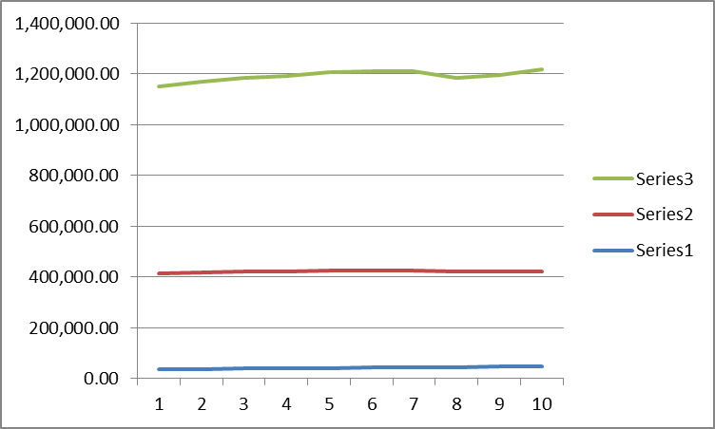
Greenhouse gas physical flow, population growth, and consumption levels are not correlated as shown by correlation value of 0.06.

Section 3
Consumption
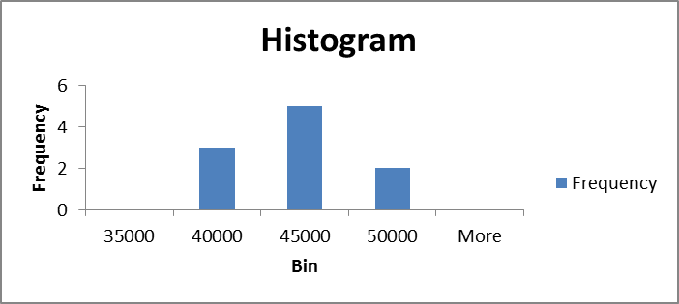
(Statistics Canada)
Both kurtosis and skewness for consumption data show they are within the acceptable zone of +2 and -2. Both mean and median are close, which shows that the data is normally distributed. This is confirmed by the histogram which bell-shaped.
Population Growth
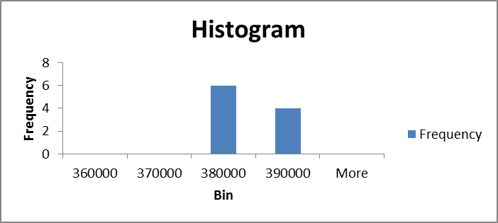
(Statistics Canada)
Measures of kurtosis and skewness are within the acceptable range of +2 and -2. Mean and median are within the same range which indicates the data follows a normal distribution. The histogram shows that the data is positively skewed, as indicated by the distribution tending towards the right side of the histogram.
Carbon Physical Flow
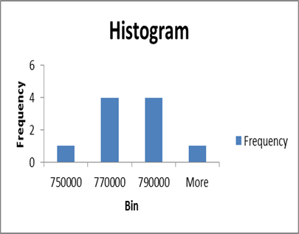
(Statistics Canada)
Both the mean and the median are within the same range, which means that the data is normally distributed. Measures of skewness and kurtosis are within the same range of +2 and -2. The histogram confirms that the data is normally distributed and is bell shaped facing downwards.
Section 4
Greenhouse Physical Flow and Consumption Levels
(Statistics Canada)
The linear model is presented by the following model Y = 607449.6 + 3.84X . The y-intercept is 607449.6 which mean under constant level of consumption this will be the level of greenhouse gas flow, while the gradient of the model is 3.84. This means that for each unit change in the value of consumption, greenhouse gas physical flow increases by 3.84 units.
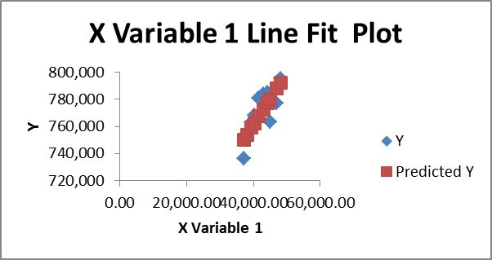
(Statistics Canada)
The line of fit graph shows that greenhouse gas physical flow is positively related to consumption and it will increase with increase in the rate of consumption. The two variables have a perfect positive correlation.
Greenhouse Physical Flow and Population Growth
The linear model for greenhouse physical flow and level of economic growth is shown by
Y = 655236.4 + 0.3X
The y-intercept is 655235.4 and shows the value of greenhouse gas physical flow when there is no perceived increase in population growth. The gradient of the model is 0.3 showing that the value of greenhouse gas increases by 0.3 units for every unit increase in the level of population growth.

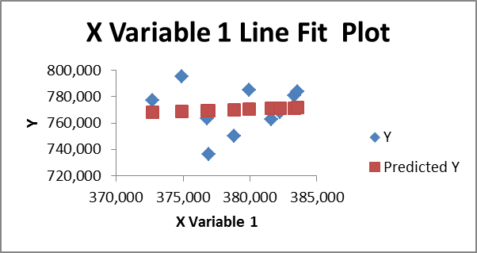
(Statistics Canada)
The scatter plot shows that the two variables have a weak positive linear relationship. The graph shows that the greenhouse gas physical flow will increase with increase as population growth increases.
Section 5
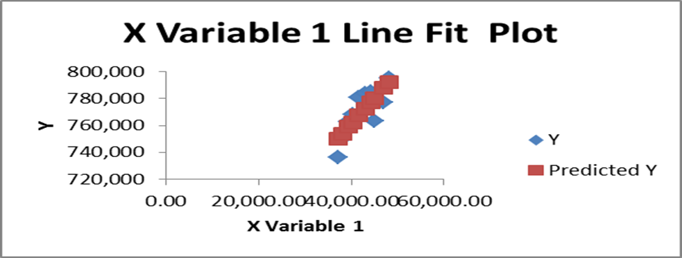
(Statistics Canada)
The point that has greatest impact in this model is (37157, 750157). This point pulls the curve downwards, giving it the steep upward slope.
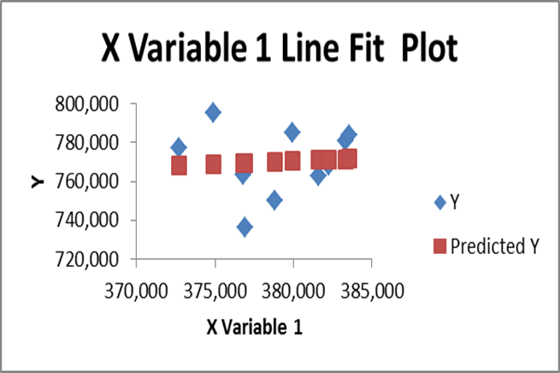
(Statistics Canada)
In this model the point that has most influence on this model is (376951, 769627). It influences the model to have the near to horizontal slope.
Section 6
The model showing the relationship between greenhouse gas physical flow and level of consumption is Y = 607449.6 + 3.84X. This relationship can be assumed to be a cause and effect because an increase in level of consumption increases the rate of greenhouse gas physical flow as shown by a positive relationship. However, it can be assumed to be a full cause and effect because consumption influences greenhouse gas physical only to a certain extent and not entirely.
On the same note, population growth has similar cause and effect relationship with greenhouse gas physical flow (Y = 655236.4 + 0.3X). However, this relationship is only to a certain extent, that is, 0.3 units for each unit change in X and not in entirety.
Section 7
As population related to greenhouse gas continue to increase, it is important to analyze the effect of consumption levels and population growth on this spread. Both population growth and consumption growth levels have a positive impact on greenhouse gas physical spread. As a level of consumption increases, greenhouse gas increases. On the other hand, population growth results in increased greenhouse gas emissions as demand of goods and physical movement of goods increases. Therefore, controlling consumption levels and rate of population growth will consequently lead to a decline in the rate of carbon emission.
Step 8
In the feedback I received from my classmate, I was required to include specifics of the greenhouse gas in terms of physical flow from each industry in relation to each contributor of emissions. The follow-up question is, “Can you give more details about physical flow?” Given the complexity of identifying each industrial player, it was important to consider the physical flow as a contributor of greenhouse gas emission and how population growth as well as consumption influence emissions. Physical flow refers to the amount of greenhouse emission from each kilometer of road travelled, and how this flow is influenced by population growth and consumption patterns. However, there are assumptions that need to be made to allow effective data analysis, and to make the analysis simpler.
Section 9
Some of the areas that would require improvement in this study is focusing on industrial specific patters of greenhouse gas emissions. It would also be prudent to evaluate the rate of greenhouse gas emission per industry and study each independent as opposed to focusing on the entire industrial greenhouse gas emission. One of the biases that I have when making conclusion is that all industries produce greenhouse gases, which might not be the case in reality. I am confident when making these conclusions but further investigation into this matter is needed.

References
Statistics Canada. Table 36-10-0225-01 Detailed household final consumption expenditure, provincial and territorial, annual (x 1,000,000)
DOI: https://doi.org/10.25318/3610022501-eng
Statistics Canada. Table 17-10-0008-01 Estimates of the components of demographic growth, annual DOI: https://doi.org/10.25318/1710000801-eng
Statistics Canada. Table 38-10-0097-01 Physical flow account for greenhouse gas emissions
DOI: https://doi.org/10.25318/3810009701-eng

